**PART 1: Connecting & Shaping the Data**

*Open a new Power BI Desktop file, and complete the following steps:*

**1)** Update your Power BI options and settings as follows:

* Deselect the "*Autodetect new relationships after data is loaded*" option in the **Data Load** tab
* Make sure that Locale for import is set to "*English (United States)*" in the **Regional Settings** tab

**2)** Connect to the **MavenMarket_Customers** csv file

* Name the table "**Customers**", and make sure that headers have been promoted
* Confirm that data types are accurate (**Note:** "*customer_id*" should be whole numbers, and both "*customer_acct_num*" and "*customer_postal_code*" should be text)
* Add a new column named "*full_name"*to merge the the "*first_name"* and "*last_name"* columns, separated by a space
* Create a new column named "*birth_year"*to extract the year from the "*birthdate"*column, and format as text

**3)** Connect to the **MavenMarket_Products** csv file

* Name the table "**Products**" and make sure that headers have been promoted
* Confirm that data types are accurate (**Note:** "*product_id*" should be whole numbers, "*product_sku*" should be text), "*product_retail_price*" and "*product_cost*" should be decimal numbers)

**4)** Connect to the **MavenMarket_Stores** csv file

* Name the table "**Stores**" and make sure that headers have been promoted
* Confirm that data types are accurate (**Note:** "*store_id*" and "*region_id*" should be whole numbers)

**5)** Connect to the **MavenMarket_Regions** csv file

* Name the table "**Regions**" and make sure that headers have been promoted
* Confirm that data types are accurate (**Note:** "*region_id*" should be whole numbers)

**6)** Connect to the **MavenMarket Calendar** csv file

* Name the table "**Calendar**" and make sure that headers have been promoted
* Use the date tools in the query editor to add the following columns:
  + *Start of Week (starting Sunday*
  + *Name of Day*
  + *Start of Month*
  + *Name of Month*
  + *Year*

**7)** Connect to the **MavenMarket_Returns** csv file

* Name the table "**Return_Data**" and make sure that headers have been promoted
* Confirm that data types are accurate (all ID columns and *quantity* should be whole numbers)

**8)** Add a new folder on your desktop (or in your documents) named "**MavenMarket Transactions**", containing both the **MavenMarket_Transactions_1997** and **MavenMarket_Transactions_1998** csv files

* Connect to the folder path, and choose "Edit" (*vs. Combine and Edit*)
* Click the "*Content*" column header (double arrow icon) to combine the files, then remove the "*Source.Name*" column
* Name the table "**Transaction_Data**", and confirm that headers have been promoted
* Confirm that data types are accurate (all ID columns and *quantity* should be whole numbers)
  + ***Spot check:****You should see data from 1/1/1997 through 12/30/1998 in the "transaction_date" column*

**9)** With the exception of the two data tables, disable "*Include in Report Refresh*", then **Close & Apply**

* Confirm that all 7 tables are now accessible within both the **RELATIONSHIPS** view and the **DATA** view

**10)** Save your .pbix file (*i.e. "****MavenMarket_Report****"*)

***Solution screenshot (for reference):***

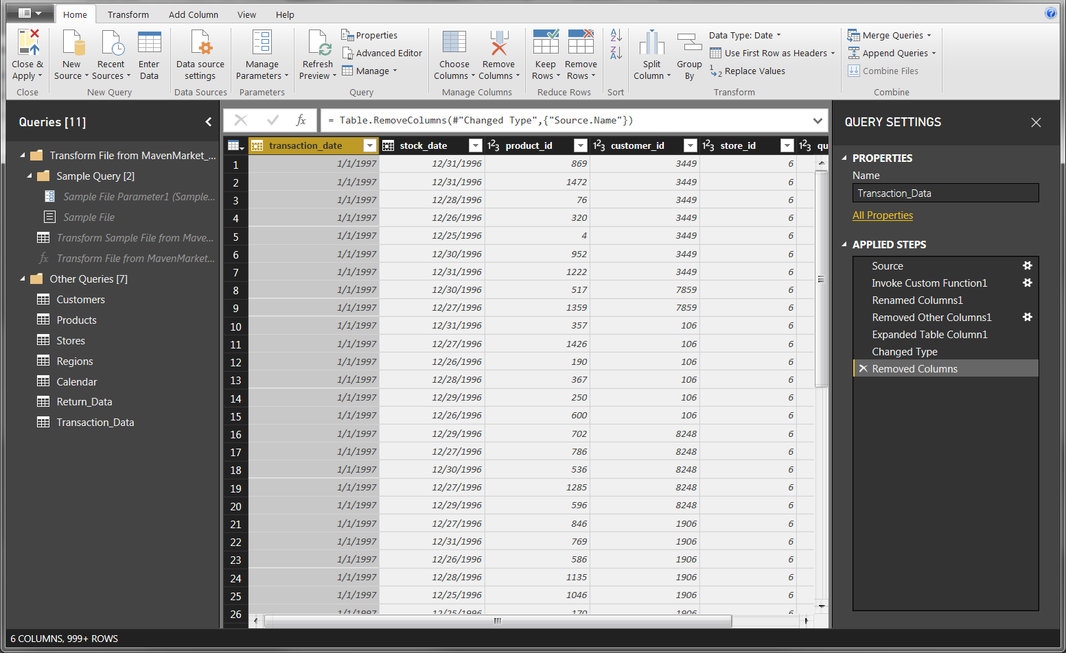

**PART 2: Creating the Data Model**

*Using the report you created in Part 1, complete the following steps:*

**1)** In the **RELATIONSHIPS** view, arrange your tables with the lookup tables above the data tables

* Connect **Transaction_Data** to **Customers**, **Products**, and **Stores** using valid primary/foreign keys
* Connect **Transaction_Data** to **Calendar** using both date fields, with an inactive "*stock_date*" relationship
* Connect **Return_Data** to **Products**, **Calendar**, and **Stores** using valid primary/foreign keys
* Connect **Stores** to **Regions** as a "snowflake" schema

**2)** Confirm the following:

* All relationships follow **one-to-many** cardinality, with primary keys (1) on the lookup side and foreign keys (*) on the data side
* Filters are all **one-way** (no two-way filters)
* Filter context flows "**downstream**" from lookup tables to data tables
* Data tables are connected via **shared lookup tables** (*not directly to each other*)

**3)** Hide all **foreign keys** in both data tables from Report View, as well as "*region_id*" from the **Stores** table

**4)** In the **DATA** view, complete the following:

* Update *all* date fields (across all tables) to the "**M/d/yyyy**" format using the formatting tools in the **Modeling** tab
* Update "*product_retail_price*", "*product_cost*", and "*discount_price*" to **Currency ($ English)** format
* In the **Customers**table, categorize "*customer_city*" as **City**, "*customer_postal_code*" as **Postal Code**, and "*customer_country*" as **Country/Region**
* In the **Stores**table, categorize "*store_city*" as **City**, "*store_state*" as **State or Province**, "*store_country*" as **Country/Region**, and "*full_address*" as **Address**

**5)** Save your .pbix file

***Solution screenshot (for reference):***

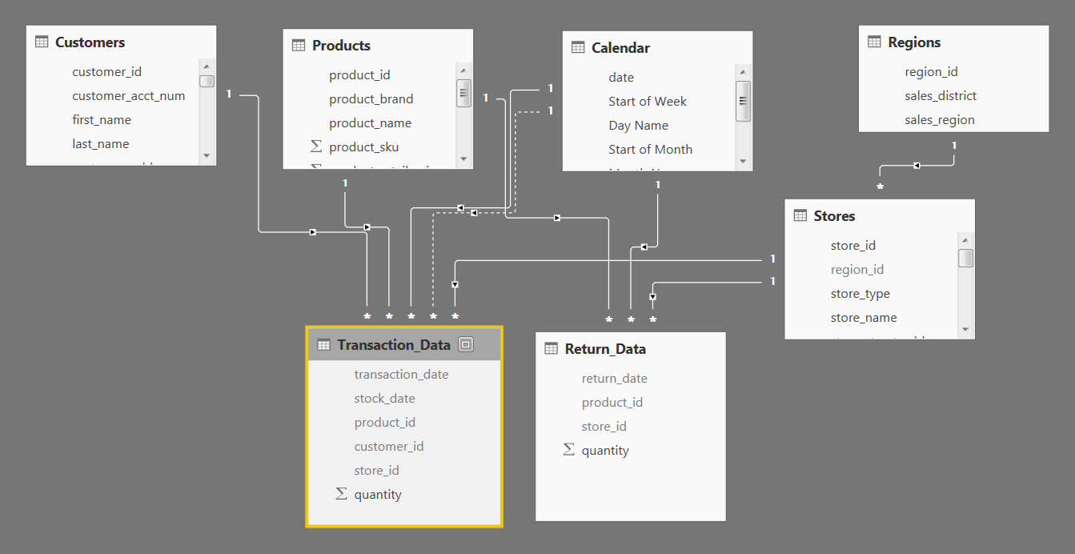

**PART 3: Adding DAX Measures**

*Using your report from Part 2, complete the following steps:*

**1)** In the **DATA** view, add the following **calculated columns**:

* In the **Calendar** table, add a column named "***Weekend***"
  + Equals "***Y***" for Saturdays or Sundays (otherwise "***N***")
* In the **Calendar** table, add a column named "***End of Month***"
  + Returns the last date of the current month for each row
* In the **Customers** table, add a column named "***Current Age***"
  + Calculates current customer ages using the "*birthdate*" column and the TODAY() function
* In the **Customers** table, add a column named "***Priority***"
  + Equals "***High***" for customers who own homes and have Golden membership cards (otherwise "***Standard***")
* In the **Customers** table, add a column named "***Short_Country***"
  + Returns the first three characters of the customer country, and converts to all uppercase
* In the **Customers** table, add a column named "***House Number***"
  + Extracts all characters/numbers before the first space in the "*customer_address*" column (***hint:****use SEARCH*)
* In the **Products** table, add a column named "***Price_Tier***"
  + Equals "***High***" if the retail price is >**$3**, "***Mid***" if the retail price is >**$1**, and "***Low***" otherwise
* In the **Stores** table, add a column named "***Years_Since_Remodel***"
  + Calculates the number of years between the current date (TODAY()) and the last remodel date

**2)** In the **REPORT** view, add the following **measures**(*Assign to tables as you see fit, and use a matrix to match the "****spot check****" values*)

* Create new measures named "**Quantity Sold**" and "**Quantity Returned**" to calculate the sum of quantity from each data table
  + ***Spot check:****You should see total Quantity Sold =****833,489****and total Quantity Returned =****8,289***
* Create new measures named "**Total Transactions**" and "**Total Returns**" to calculate the count of rows from each data table
  + ***Spot check:****You should see****269,720****transactions and****7,087****returns*
* Create a new measure named "**Return Rate**" to calculate the ratio of quantity returned to quantity sold (format as %)
  + ***Spot check:****You should see an overall return rate of****0.99%***
* Create new measures named "**All Transactions**" and "**All Returns**" to calculate grand total transactions and returns (regardless of filter context)
  + ***Spot check:****You should see****269,720****transactions and****7,087****returns across all rows (test with product_brand on rows)*
* Create a new measure to calculate "**Total Revenue**" based on transaction quantity and product retail price, and format as $ (***hint:****you'll need an iterator*)
  + ***Spot check:****You should see a total revenue of****$1,764,546***
* Create a new measure to calculate "**Total Cost**" based on transaction quantity and product cost, and format as $ (***hint:****you'll need an iterator*)
  + ***Spot check:****You should see a total cost of****$711,728***
* Create a new measure named "**Total Profit**" to calculate total revenue minus total cost, and format as $
  + ***Spot check:****You should see a total profit of****$1,052,819***
* Create a new measure to calculate "**Profit Margin**" by dividing total profit by total revenue calculate total revenue (format as %)
  + ***Spot check:****You should see an overall profit margin of****59.67%***
* Create a new measure named "**Unique Products**" to calculate the number of unique product names in the **Products** table
  + ***Spot check:****You should see****1,560****unique products*
* Create a new measure named "**YTD Revenue**" to calculate year-to-date total revenue, and format as $
  + ***Spot check:****Create a matrix with "****Start of Month****" on rows; you should see****$872,924****in YTD Revenue in September 1998*
* Create new measures named  "**Last Month Transactions**", "**Last Month Revenue**", "**Last Month Profit**", and "**Last Month Returns**"
  + ***Spot check:****Create a matrix with "****Start of Month****" on rows to confirm accuracy*
* Create a new measure named "**Revenue Target**" based on a 5% lift over the previous month revenue, and format as $
  + ***Spot check:****You should see a Revenue Target of****$99,223****in March 1998*

***(See COMPLETE report file to check your DAX formulas)***

**PART 4: Building the Report**

*For the final phase of the project, you can either follow the instructions to recreate the report shown below, or design your own version -- the choice is yours!*

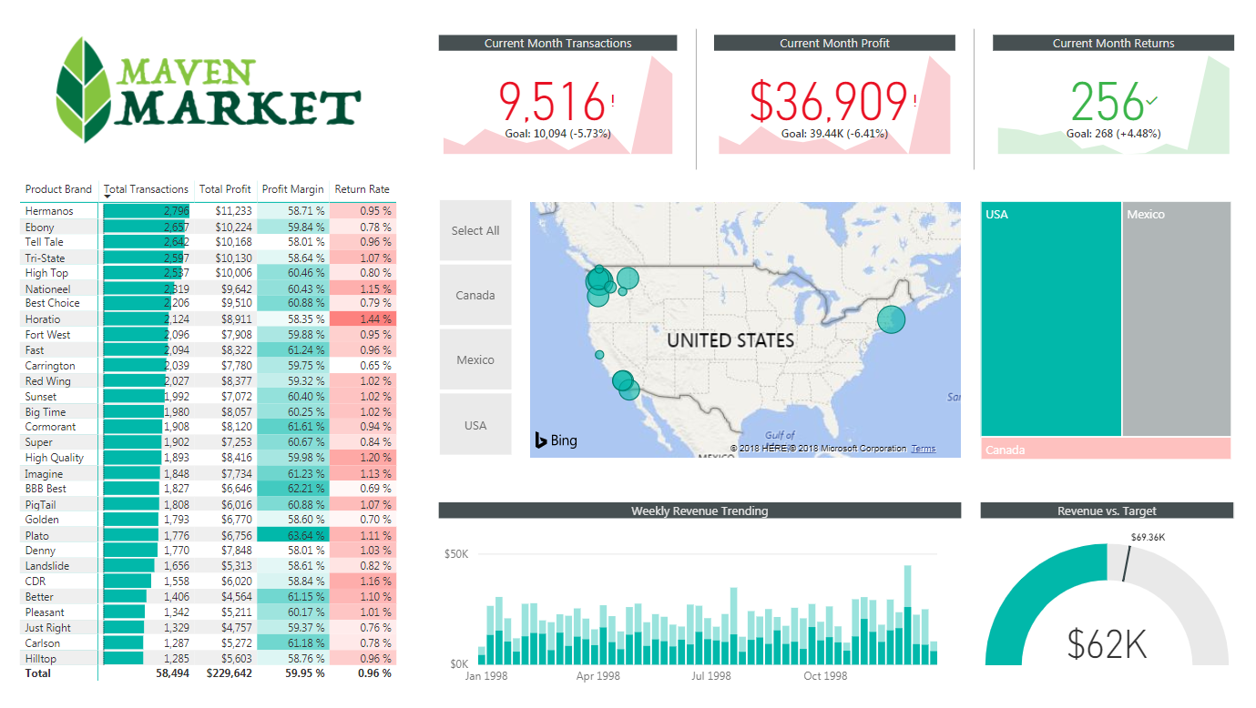

**1)** Rename the tab "**Topline Performance**" and insert the Maven Market logo

**2)** Insert a **Matrix** visual to show **Total Transactions**, **Total Profit**, **Profit Margin**, and **Return Rate** by **Product_Brand**(*on rows*)

* Add conditional formatting to show **data bars** on the Total Transactions column, and **color scales** on Profit Margin (*White to Green*) and Return Rate (*White to Red*)
* Add a visual level**Top N** filter to only show the top 30 product brands, then sort descending by Total Transactions

**3)**Add a **KPI Card** to show **Total Transactions**, with **Start of Month** as the trend axis and **Last Month Transactions** as the target goal

* Update the title to "***Current Month Transactions***", and format as you see fit
* Create two more copies: one for **Total Profit**(*vs. Last month Profit*) and one for **Total Returns** (*vs. Last Month Returns*)
  + Make sure to update titles, and change the Returns chart to color coding to "*Low is Good*"

**4)**Add a **Map** visual to show **Total Transactions** by store city

* Add a slicer for store country
  + Under the "selection controls" menu in the formatting pane, activate the "***Show Select All***" option
  + **Pro Tip:** Change the orientation in the "General" formatting menu to**horizontal** and resize to create a *vertical*stack (rather than a list)

**5)** Next to the map, add a **Treemap** visual to break down **Total Transactions** by store country

* Pull in **store_state** and **store_city**beneath **store_country** in the "Group" field to enable drill-up and drill-down functionality

**6)** Beneath the map, add a **Column Chart** to show **Total Revenue** by week, and format as you see fit

* Add a **report level filter** to only show data for 1998
* Update the title to "***Weekly Revenue Trending***"

**7)** In the lower right, add a **Gauge Chart** to show **Total Revenue** against**Revenue Target**(*as either "target value" or "maximum value"*)

* Add a visual level **Top N** filter to show the latest **Start of Month**
* Remove data labels, and update the title to "***Revenue vs. Target***"

**8)**Select the Matrix and activate the  **Edit interactions** option to prevent the Treemap from filtering